OGDEN’S ENCYCLOPEDIA OF RADIO HORROR—“P” Copyright © 2010 Vanished Voices OTR
`

P 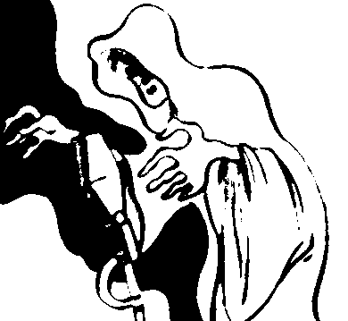

PETER QUILL

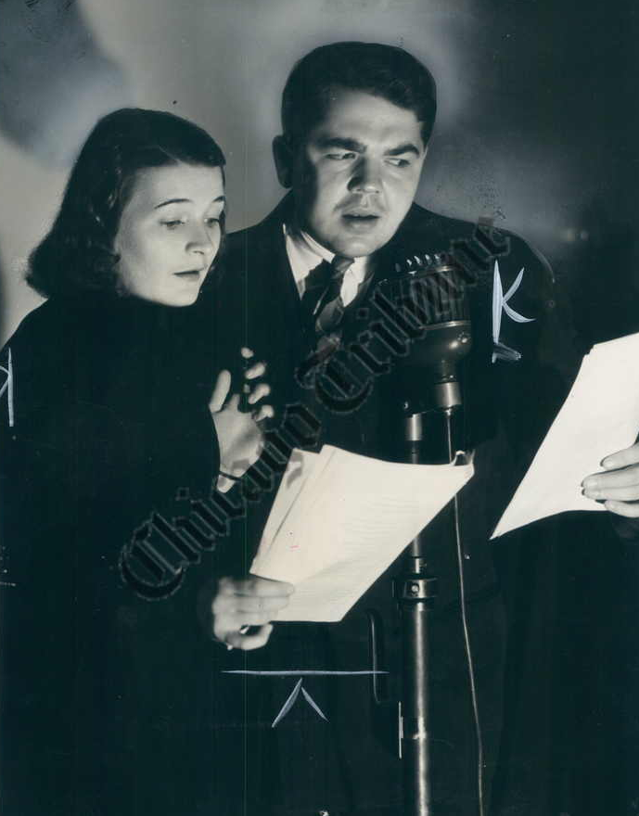
“NOV 10, 1940—Alice Hill as Gail Carson
and Marvin Mueller as Peter Quill in a
tense moment in broadcast of the Peter
Quill series heard 3:00 to 3:30 p. m. on
Sundays over W-G-N.”

THE PHANTOM RICKSHAW
[SHORT-STORY]

TALES OF THE TITANS (
[Friday—
July 21, 1933 “The Phantom Rickshaw”

POE NO ICHIZOKU
[RADIO-SERIAL]
Poe-inspired manga that later became a radio series.
WIKIPEDIA: “Pog no Ichizoku was adapted as radio drama broadcast by NHK-FM between January 1 and January 6, 1980. It was directed by Tokio Ootani from a script by Sunao Takata, with sound effects by Masakazu Haraquti and Akira Iwai. It starred Kouji Ishitobi as the Baron and Haruka Kurara as the Baron’s wife.
“Manga. Poe no Ichizoku was written and illustrated by Moto Hagio and serialized by Shogakukan in Flower Comics from March 1972 to June 1976. The individual chapters were collected in nine tankobon volumes under the Flower Comics imprint, with the first volume published on March 28, 1974 and the final volume on January 25, 1978. Shogakukan later re-released the entire series in three bunkoban volumes on July 17, 1998, and then again in two wide-ban volumes on November 26, 2007 and December 21, 2007, respectively.
“Poe no Ichizoku (lit. ‘The Poe Family’) is a Japanese shojo historical manga by Moto Hagio that depicts a family of vampires from the 18thh to the 20tth centuries. The two main characters, Edgar Portsnell and Allan Twilight, as well as the family are named after Edgar Allan Poe… Poe no Ichizoku received the 1976 Shogakukan Manga Award for shonen manga… In 1974, the first print run of the first volume (30,000 copies) sold out in one day, which permitted Hagio to continue with more stories set in the Poe universe. It was inspired by Shotaro Ishimori’s story ‘Mist, Roses and Stars.’
“Edgar was born as an illegitimate child to Earl Evans. After the birth of Edgar’s siter, Marybell, four years later, his step mother ordered the nurse to kill Edgar and Marybell. The nurse did not kill them but abandoned Marybell and Edgar in the woods, expecting them to die of starvation, where they were discovered by Hannah Poe. She took them to her mansion near the village of Scotty. Hannah looked after the siblings. When Edgar was eleven, he got to know the secret that Hannah and people in the mansion were Vampanellas. He was forced to promise he would turn into a Vampanella, a member of Poe family, when he became an adult. Marybell was adopted by Baron Art due to Edgar’s request. When he was 14 years of age, Hannah was killed by a villager and the villagers got to know the secret of the mansion. Edgar was turned into a vampire by King Poe, effectively forcing him to join the Poe family, before the family escaped from the villagers.
“Three years later, Earl Evans’ eldest son, Oswald, met Marybell and Edgar. Marybell attempted to kill Edgar because he is a vampire. However, she changed her mind when Edgar kept being nice and loving her very much. Edgar took her into the family of Poe. Edgar is adopted by a baron and his wife, Sheila Portsnell, who is also a vampire. The Portsnells who owns the port. However, Edgar and Marybell could not stay under the care of the baron for long because they remained 14 and 13, respectively.”

THE POND
[SHORT-STORY]

THIS IS MY BEST (CBS)
[Tuesday—
May 7, 1946 “The Pond”
[LIMA NEWS: “Ida Lupino, one of the screen’s leading dramatic actresses, portrays the leading role… The story, which appeared in Good Housekeeping magazine, has been adapted for radio by Carlton E. Morse. It is the story of a young woman who discovers on the grounds of her new suburban home a pond which she has seen before in a vivid dream, with her dead body floating under the ice. The dream is linked with a definite future date, and her mental tension increases as the day draws near…”]

